* **[How to create a promoted links list (PART 2)](https://sharepoint.rackspace.com/learning/articles/Pages/SharePoint-2013--how-to-create-a-promoted-links-list-app-part-2.aspx)**

Welcome back! If you haven’t read Part 1 you may want to do so now.  In Part 1 we created a Promoted Links list called “PromotedIcons” and added a new “Company Tasks” Link.  In part 2 we will cover adding the “PromotedIcons ” web part to a SharePoint page.

1. From your SharePoint site, open any page you would like, in this example I will edit my Home page. 

2. At the top of the page click **Page**, to expand the ribbon.

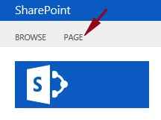

3. In the Edit section click **Edit**.

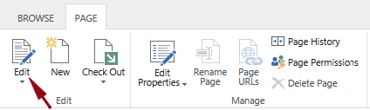

4. Click anywhere within the outermost grey line and press **Enter**.

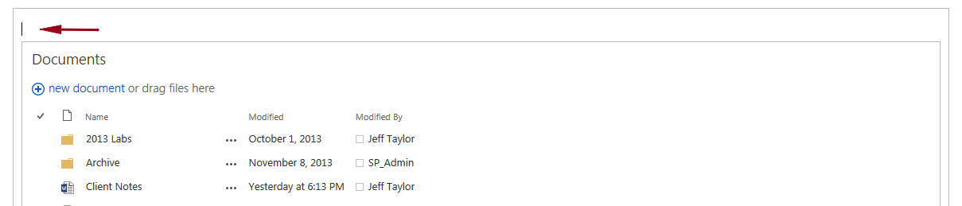

5. At the top of the page click the **INSERT** tab.

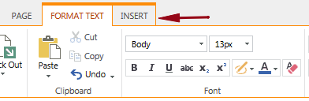

6. In the Parts section click **Web Part**.

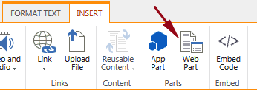

7. Make sure the Apps category is selected and under Parts click “**PromotedIcons**” (or whatever you called your Promoted Links list).

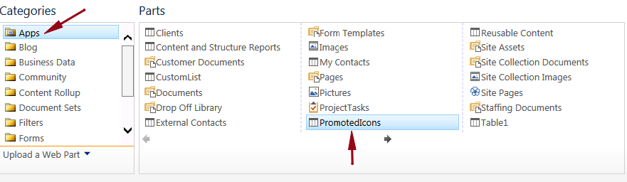

8. Verify the “PromotedIcons” list is selected under About the Part and click **Add**.

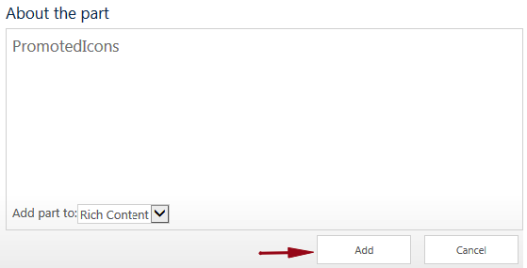

The “PromotedIcons” web part will now be added to my SharePoint page.  We’re not quite done yet; the page still needs to be saved.

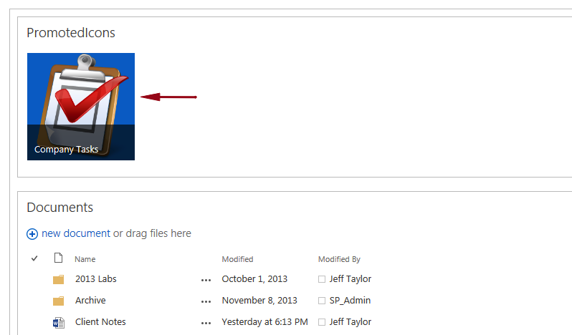

9. On the ribbon, click **Save**.

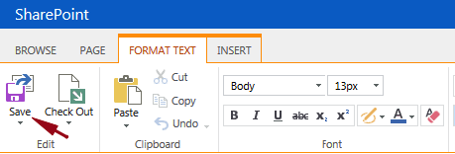

Easy enough! You have successfully added your Promoted Links list to a SharePoint page.

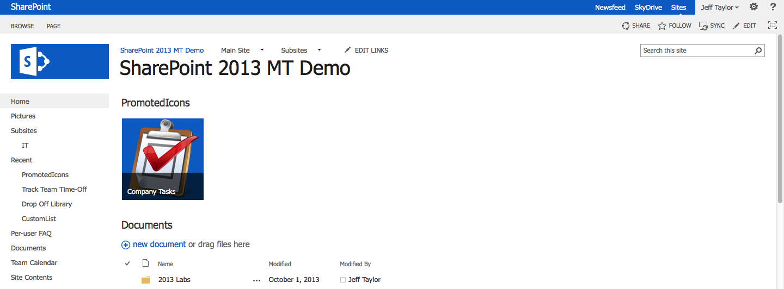

Par​t 3 will go over adding a new link, editing a link, and modifying the default view for the “PromotedIcons” list.